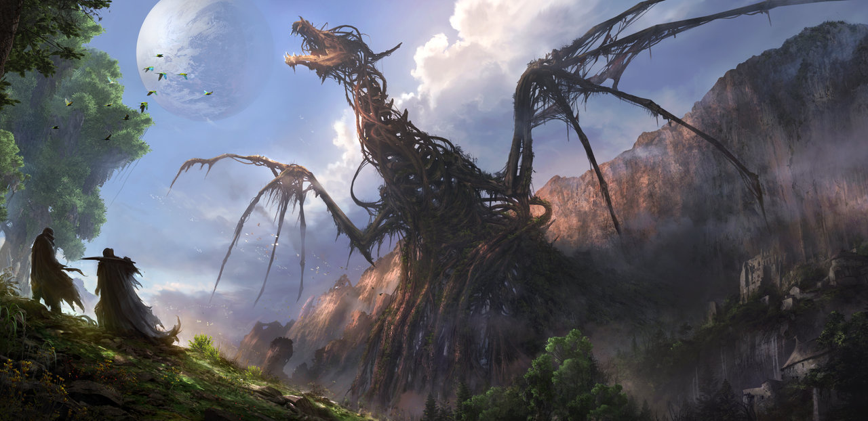

http://www.deviantart.com/art/Entombed-378121081

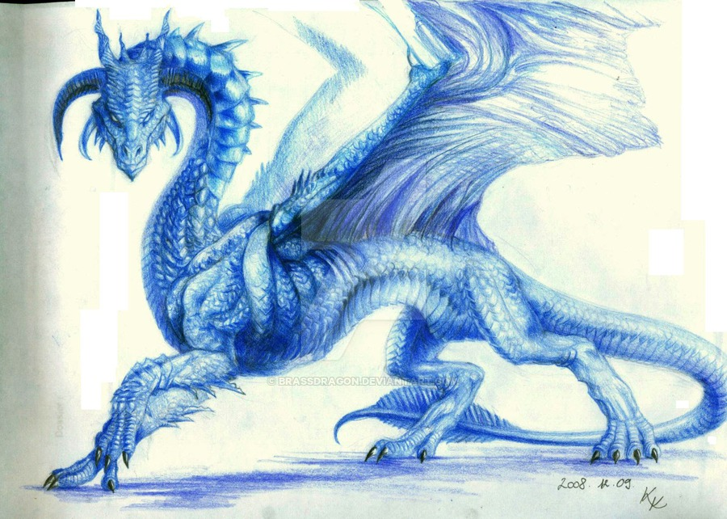

<http://www.deviantart.com/art/Sapphire-Dragon-Reference-105886482>

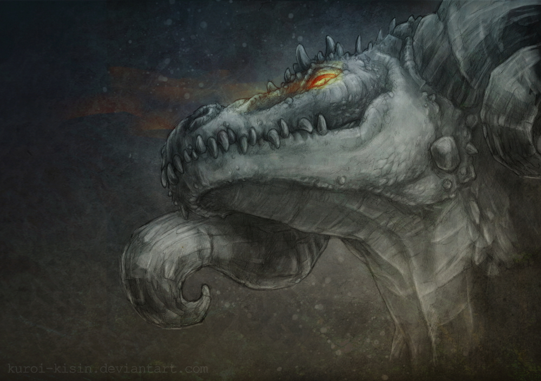

<http://www.deviantart.com/art/Dragon-298931354>

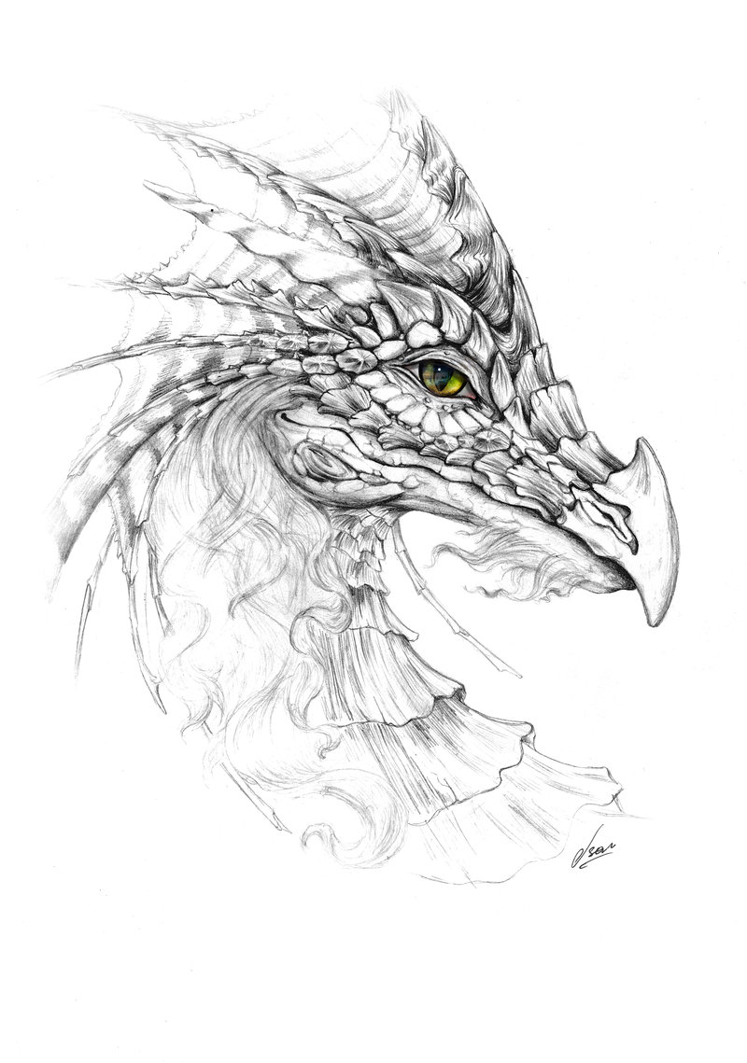

<http://www.deviantart.com/art/Dragon-22812867>

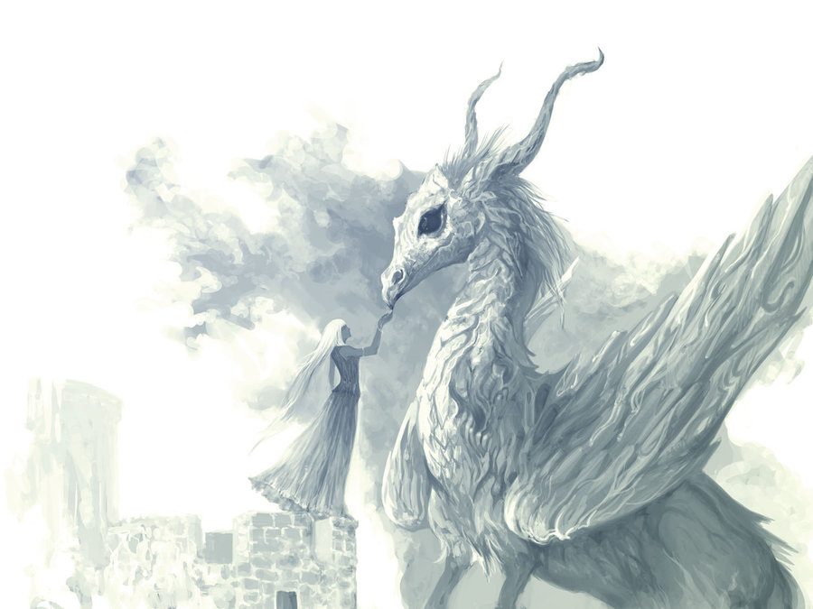

<http://www.deviantart.com/art/Dragon-Woman110419-205389565>

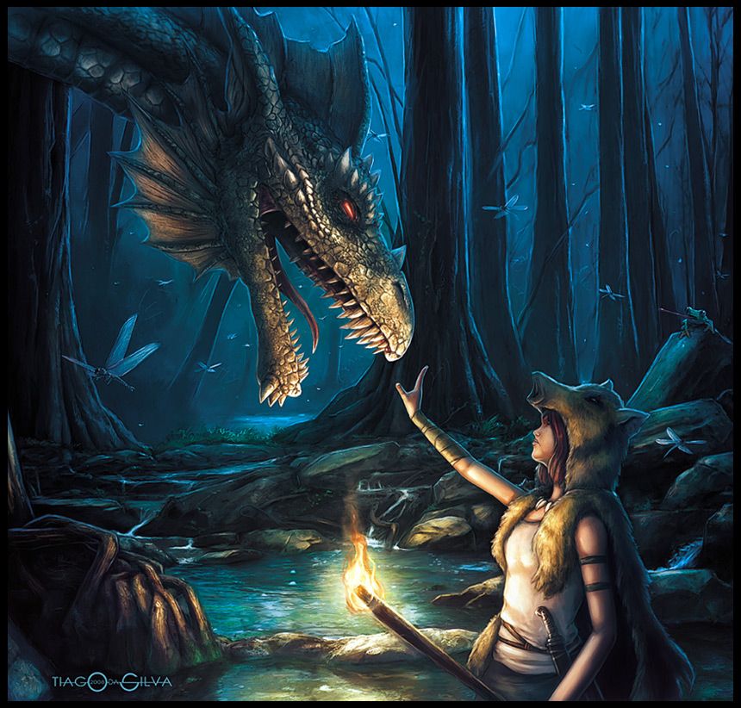

<http://www.deviantart.com/art/The-Dragon-Master-94832920>

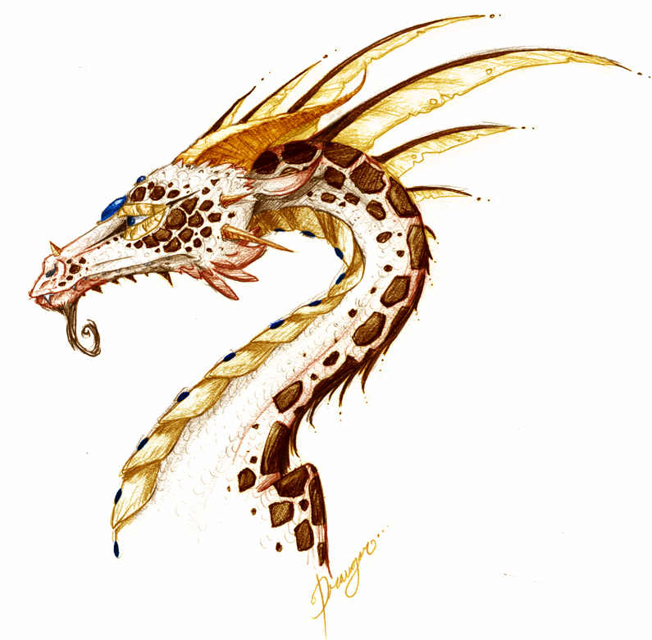

<http://www.deviantart.com/art/Dragon-70028248>

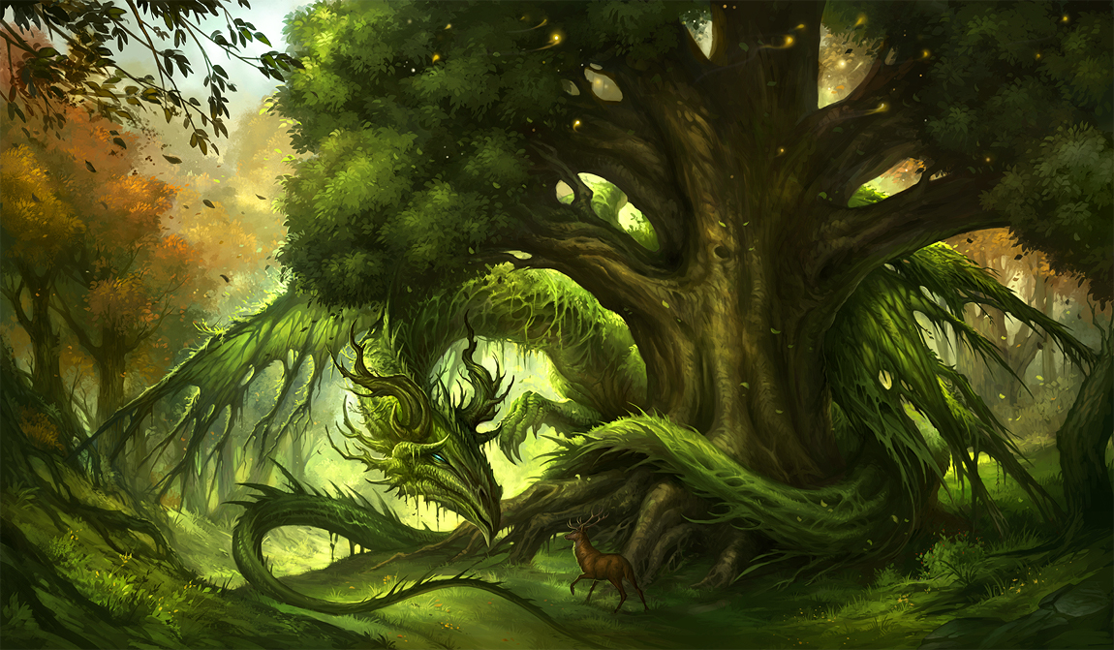

<http://www.deviantart.com/art/Green-Dragon-392101725>

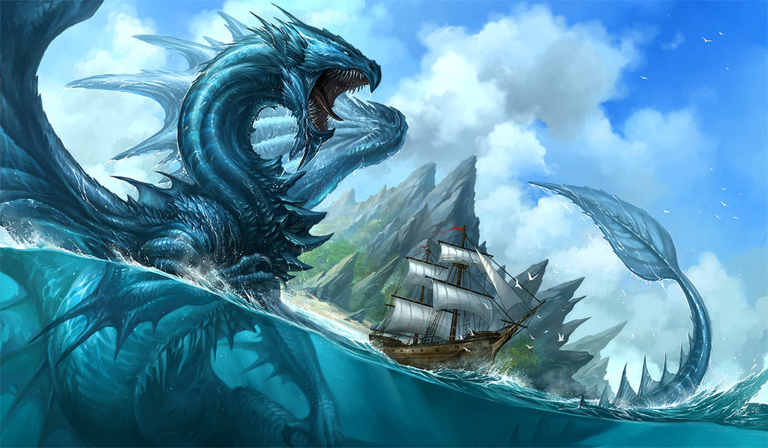

<http://www.deviantart.com/art/Blue-Dragon-392820789>

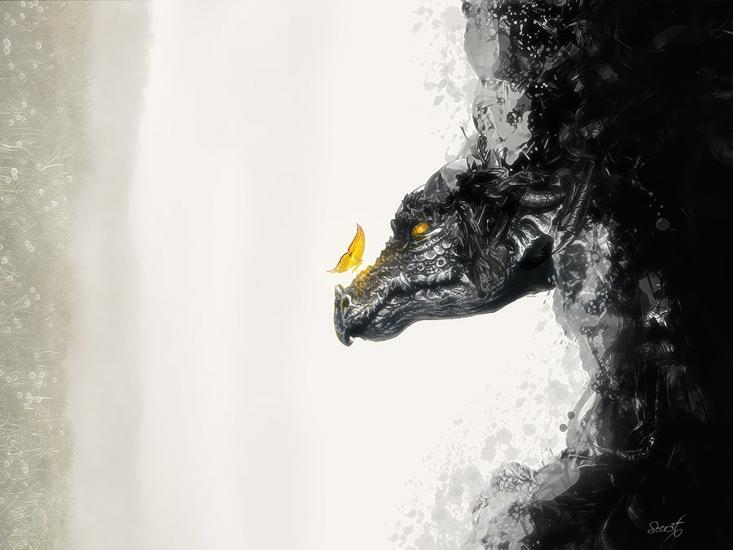

http://www.deviantart.com/art/The-Dragon-269031561